End User Requirements
Multi Cost/Pricing Rev 4

Repacorp

Document Approval
Approver | Approved Date | Rejected Date | Comments
Brian Chapple
Rochelle Heinl

Part 1 Functionality Overview

Objectives (Why are we doing this?)
  - To provide a location that allows users to setup and view qty and pricing breaks for sellable items.
  - Allow users to establish cost and retail values for items given certain qty orders in a generic fashion as well as customer specific.
  - Allow the system to use the established cost for the qty specified (at work order completion).
  - Allow users to view and alter this data from the item master and the configurator interface (when running the configurator).
  - To ensure there is security in place to set the screen to read only for users.
  - To alter the work order completion process in that it updates the costs in such a way that doing a credit note will return the inventory record at the cost it was removed at.

High Level Requirements.
Items will have custom selling price (Retail) for different qty ordered.
Customers may also have specific selling price (Retail) for different qty ordered for an item(s).
Customers may also have a “Blanket” agreement for particular items guaranteeing them a specific price.

The default method of establishing cost does not work for Repacorp and they need to specify what cost to use.
Costs will vary from qty to qty as well as customer specific and blanket agreements.
For STOCK items, the cost is a set value regardless of the qty ordered or completed.

Repacorp requires the ability to set all theses combinations up as well as view them directly in the application and not via excel.

Business Process
Note that we have reviewed the customer item numbering screen that is in Seradex now within the CRM system:
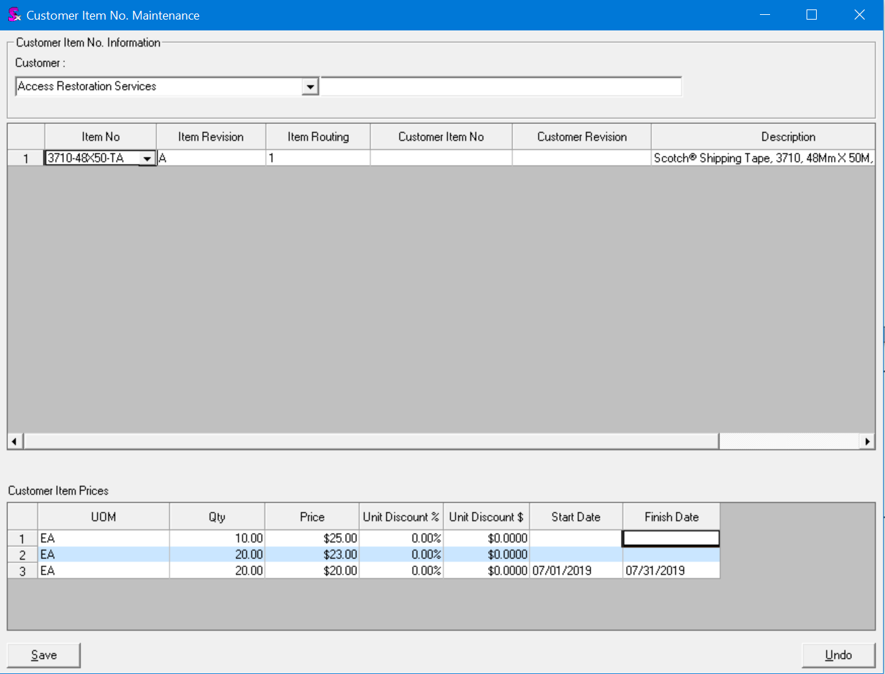

We are asking to extend this functionality:
- Make this available from within the Product Configurator.
  - When running the configurator, via the tools menu, the option should be their to load this screen and interact with it fully.
  - NOTE: if they user opens a “Closed” transaction but uses the tools menu to get to this new interface, they must be able to edit the details there (don’t restrict access).
- Item Editor as a new tab visible for both make and buy items.
  - Needs to be for both as this will hold both the selling price and the manufacturing cost. As such, they need to record this information and ensure sales related transactions and production related transactions have access to this information.
- With CRM Module against a particular customer (would load pre-filtered to that one customer).
  - So . . . if we set up a customer item: RT-4-6-1000-3 and item: LX-3x1-4250-3 . . . would a screen under the customer show both of these items in one screen?
    - YES
  - I was thinking this would be done by a search because this pricing would be linked to an item, not necessarily a customer.
    - Since you are coming in at things via the CRM system ,we know the customer and as such can show you what is already setup against that customer.
- Provide Security such that the form is either editable or read only depending on the user.
  - How will this security be managed and set up?
    - Security will be as core handles things. There is a form name and control option that is setup in the database and then applied to the users profile.

From Item Master.
- Users will choose an item via the standard item editor interface.
- Users will enter the edit mode in that they see all the details of the item (right click or via the tools menu)

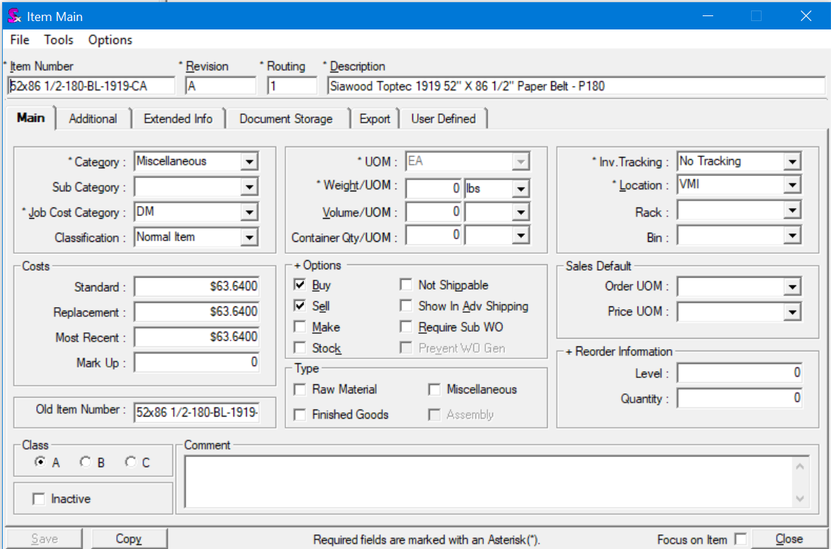
Add new tab for pricing information.

- If the item has the SELL or MAKE flag checked, users will see a Selling Price Tab.
- This tab will allow users to specify the following in regards to selling prices.
    - Add a filter row at the top of the view for searching – all columns will be searchable just like all Seradex Searches.
    - To delete a line, users will select the line and press delete.
      - It would be beneficial if the option to mass delete numerous lines was present. As time goes on, the history will start to stack up. So purging this on demand would be required.
      - Really want this. If we can’t do this, we are going to need someway to purge out the old records.
    - Also, confirm we can set logic so if a “Start date” is 5 years old, the system will automatically remove the data from the screen.
      - This type of rule is complicated. I think it would be more cost effective to do this manually.
    - Tab layout will be set up like this layout from left to right:
      - DO NOT allow column moving. However, we may need to allow them to stretch some of the fields.
      - Ensure the customer item number auto stretches to accommodate (within reason).
      - Would it be possible to control this via a SQL Query in that they could dictate the order of the columns like we do in Search?

  - Customer
    - Allows for users to specify that this pricing is specific for a certain customer.
    - If a customer is not listed, the pricing will apply to anyone who selects this item.
    - This needs to be a drop down on the customer so that the users can pick the customer that they want.
      - If you pick a customer #, it fills in the customer name.
      - If you pick a customername, if fills in the customer #.
      - Also, both of these need to have the type ahead to allow them to find the customer that they want.
  - Customer Item No (do we default this to sxitem?)
    - We would want our team to set a specific item number which will override the sxitem
      - Will doing this allow the user to no longer have to go into the CRM, Tools menu and set up the Items specific to a customer?
        - So, it would auto load into a sales order…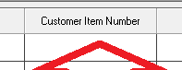
    - This will be blank by default. If they enter a value here, then this will be the customers Item No. However, blank means that we are going to use the item master description.
  - Qty
    - There will be 5 decimal places just like in all other Seradex interfaces
Will change this to use the module setup. This way you can control it and have the ability to change it if need be. We would have to use the settings from the Inventory Module.
NOTE: the preference to control the decimals will come from the form specific on SALEORDER ONLY.
    - Allows for the user to specify a qty for this pricing. This would be for qty’s up to this number
    - Would like a comma to be present in number.
    - Sort this column :
      - First by most recent Start date
      - Second by smallest quantity up to largest quantity
    - IN the case where there are numerous entries for qty (10,15,19), the system will need to be able to handle this and pick the correct on when users are entering orders.
  - Retail
    - Allows the user to specify the selling price for that item.
      - Retail means that any “sellable” transaction (invoice, credits, estimates, sales..) will need to check here first to see if a retail value is specified for the qty and date range (blanket flagged records always win and come first).
      - Price will have 5 decimal places like the rest of Seradex Interfaces.
        - Control this via the form specific settings
  - UOM
    - Note that this is going to be the item master UOM in read only format.
      - This means however, that if a sales order is entered in a different UOM, the system must apply the correct conversion factor to both the RETAIL and COST values.
  - Cost
    - Allows the user to specify what the cost will be for that row of data.
      - Costs will be used at the work order completion process. Currently, their logic is to look at the STD Cost of the item and use that. However, this will be changed to always come here to get the cost.
      - This will be a mandatory field.
Note: This will make the STD cost…almost obsolete. However, could we have it that on WO completion, it just pushes the most recent cost into the std cost?
      - In the case where no COST is set, the system will revert to standard functionality to determine the cost of the produced product.
      - This should have 5 decimal places like the rest of Seradex interfaces
Needs to pull from application preferences.

  - Blanket (checkbox).
    - This would be the final layout screen:
    - This will be used to indicate that there is a blanket agreement with the customer for that item.
      - Make this a check box. Default it to no.
    - Is this going to be on the line of the quantity which the costing should pull from. Discussion was had surrounding on a blanket, the costing, for example, is for 2,000,000 – however, the product is built at 500,000 a time. need a way to tell the system what the master cost and retail is for that blanket item.
    - During WO completion, if the item being produced is found to have a blanket record and the date of WO completion is within the START and END dates of that record, the system will use that cost. Otherwise, it will use the additional logic.
    - If I quoted a blanket and the customer asked for 2 quantities on the quote. As the user, I would load in both quantities .. . . then, select “yes” on the item which I want the pricing to pull from
      - Additional logic and sequence will be defined later in this document.
        - If the Start Date is the most recent, and the Blanket = “yes”, use this cost and retail.
        - If the blankets overlap, you will have to change to the new retail line
        - only allow ONE "yes” under the Blanket column.
          - If there is a “yes” selected, you will ignore other logic and just select the cost and retail regardless of the quantity built on work order or sold on sales order.
          - If the date does not fit into the start to end date timeline and there is no date series, but, a line with blanket =”yes”, put an alert and do not allow the order to save.
  - Date (read only)
    - Used to record the date that the data was changed/entered
      - This will auto record and not be editable.
  - User Created (read only)
    - If the user can’t be determined due to bad data, an error message should be displayed and the user should not be allowed to make any changes to the data on this new tab.
    - Records the user that made the change or added records.
    - I appreciate the editing date and user were added, that is great.
      - Just to clarify, this only shows the most recent, last change? Or, just the date the line was created?
        - EX: if the line was created on 9-15 and then on 9-19 someone goes in and changes the retail, what will the line Date and User show?
        - It would only show the last person to modify the data on that line.
  - Notes ( 8000 characters)
    - Allows the user to record notes in regards to the changes that are being made.
    - To keep the screen clean, it needs to just display a single line by default. The users can then double click in this box to open up a larger box to view/edit the notes.
    - Do not make this a wrapping box, but, if you double click in the box, it will expand and you can see all of the text.

  - Start Date (date format…with a calendar option)
    - Used to allow the user to specify when (and if) the pricing will take effect.
      - If a user begins to add a new row, this will default to today’s date. However, the user can modify this to a date in the future or the past (to allow them to record truly when the pricing was negotiated).
      - This will be a mandatory field and must be filled in.
        - I am thinking differently here. I think the start date should be auto entered as the date of the entry. Allow it to be changeable if the start date is in the future, or, the user should have entered it previously
        - However, do not require an end date
        - As discussed previously, if there is no end date, the price is good forever. So, the system needs to check an end date and if not there, assume as long as it is after the start date, then it is good.
    - Users need to be able to modify this information in the situation where they need to come back in at a later time and modify things.
  - End Date
    - Same functions as the start date option.
    - This will be blank by default.
    - Used to allow the user to specify an expiration date for the price and qty
    - Note that this field is optional. If no end date is found, that indicates that the pricing/costs for that row are indefinite (until an end date is specified).
      - During this project, set up an automatic alert to the CSR/Sales/CSR manager showing the following:
        - Send one alert 30 days BEFORE the blanket expires if there is still inventory in the system under that item, making the CSR aware to remember to work with customer to ship inventory.
        - Then, one week BEFORE the blanket end date
        - Then, one week AFTER the blanket end date
        - Then, one month AFTER the blanket end date
        - After two months, we hit it every day and include the manager.

Sort Order:
Sort first by Start Date
Then by quantity
Then by customer number
Example:
Optionally, the system also needs to support copy and paste. The concept on this is that users may setup the data in excel. They could then select all the rows of data and paste them into an empty row on the interface. This would be similar to how database work in that if the data you selected in your copy aligns with the columns and data types that you are pasting into, it works. Otherwise it should not allow you to paste in the form.
Option 2 – create an excel template file that they can fill in and then load to this screen. This would be an “append” function.
NOTE: please quote both options. The excel file upload would be the ideal solution but it depends on costs and delivery time.

From Within Configurator.
During the configuration of a new or existing item, users will need to have access to the new screen to setup all their costing and pricing.
We would request that a menu option be present to allow the users to get to this screen and add/alter the data if need be.
Note that security must be enforced in that if the user is setup as Read-only, that setting is applied.
The process would be:
- User runs the configurator.
- New Item (Mastered) being created.
  - Standard config processes no change here in that the user saves the line.
  - User goes to the VIEW/TOOLS menu in the configurator.
    - Seradex will need to determine a standard menu to use.

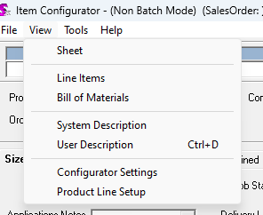

  - New menu choice is there to call open this new item pricing screen.
    - Note you can come in here at any time as long as you have not edited the configuration (save button active).
  - Screen loads.
  - It should auto fill in the customer for the user.
  - User now starts to either manually fill in the different qty, uoms ect on the screen.
  - User presses save to commit their changes.
- Once the user leaves that screen, the system should check the configuration in regards to the selling price. The reason is that although the configurator created a selling price, the user may have changed things on the new screen and the system needs to take that into consideration.
  - NOTE, there may be a situation where the configurator was started and a qty ordered was 5,000. However, when the user used the tools menu, the first available qty break was set at 10,000. This means that their configuration is not valid now as the system will not be able to determine the correct price/cost to use. As such, when returning to the configurator interface, the system will need to check for this and present a error message stopping the user from closing the configurator interface without first updating the qty ordered (which may and in most cases result in a reconfigure action to rebuild the bom properly).

From Within CRM
When the users are looking at a customer/prospect from within CRM, if they use the menu options to go to customer pricing, the proposed new screen will come up.
This screen, since it was started from CRM and there is a customer/prospect selected, will need to filter out all other data that is not related to that customer.
Again, security needs to be followed to ensure that if the user is read-only, that is applied.
If the user adds records to this screen from within the CRM, then we need to set the transaction type to CRM but leave the transaction # empty (since there is no transaction for CRM).

Process Flow:
Sales Order/Invoice/Credit Note/Service Order – all modules where pricing is calculated (not estimates).
We are asking that the system then be altered to use this new information.
NOTE: this does not address the issue of converting a estimate to a sales order. As such, when converting, we must check at that point.
Any item that is sell or make must have cost/retail information filled in.
I believe that the current process for determining the selling price is:
- Check the item master for a price list entry that matches the currency of the order.
- Check the customer Item Number system in CRM for useable entry there.
- Check the pricelist.xls file.
This will result in this system being the only way to determine selling price.

Pricing Rules to follow:
- No record found at all.
- Item exists but not tagged to that customer (item only, blank customer information).
- Item exists and is tagged to that customer without a blanket agreement.
- Item exists and is tagged to that customer with a blanket agreement.

General Note on Qty Lookups
When looking up the qty break, the system will take the qty ordered and will into this table in that the qty ordered is >= a record but < the next highest.
Example:
- Qty ordered = 8,000. The system would use the costing for the 1,000 record.
- Qty ordered = 13,000. The system would use the costing for 10,000 record
- Qty ordered = 5. The system will generate an error as there is no qty in the pricing logic to handle that scenario

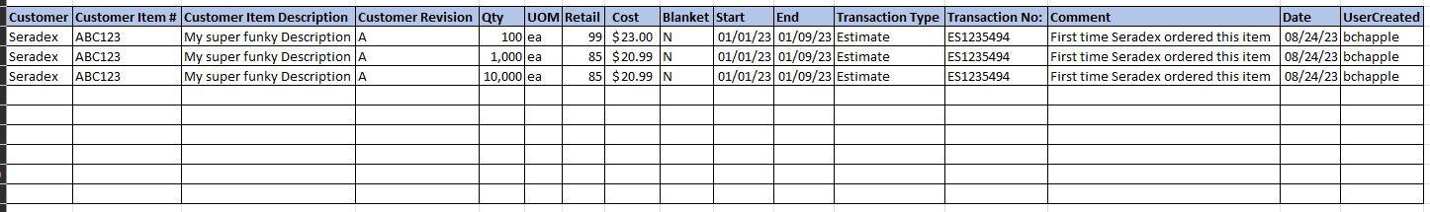

Using the table above as our sample

No record found at all.
In this scenario, a user is working on a transaction where selling price needs to be determined.
When the user enters the item # (rev and routing included), the system looks up to this new system to find the correct record for pricing. However, no match is found.
- No item against the customer with a blanket within the date range.
- No item against the customer within the date range.
- No item within the date range.

NOTE: the above always uses the qty logic in that the qty ordered must be >= a record.
This indicates that this item has not been setup properly or the setup is incomplete.
An error message must be displayed and the item referenced to tell them which Line(s) have issues and they must correct it. Don’t allow them to save the order.
This ensures that the user setups up the item first.
Remember that BLANKET always wins.

Item exists but not tagged to that customer (item only, blank customer information)
In this scenario, user is working on a transaction where a selling price needs to be determined.
The system will check for a record and first looks up looking for a record against the customer. When no record is found, it will then look for a record that is not associated to any customer at all.
- No item against the customer with a blanket within the date range.
- No item against the customer within the date range.
- Record is found for the item and is within the date range
If it finds a record and the date is within the start and end date of that record, the system will use that selling price.
If it can’t find a record or the records found are not within the date range, the system will fall back to “No record found at all”
Remember that BLANKET always wins

Item exists and is tagged to that customer without a blanket agreement
In this scenario, user is working on a transaction where a selling price needs to be determined.
The system will check for a record against the customer (same as the above statements).
  - No item exists against the customer with a blanket within the date range.
  - Record exists for the item against the customer within the date range
Remember that BLANKET always wins

Item exists and is tagged to that customer with a blanket agreement.
Same as the above, system is looking for the price.
- Item exists for against the customer with a blanket within the date range

      - If no end date, use that row
Remember that BLANKET always wins

Qty logic does not apply to a blanket.

Work Order Completion.
Repacorp has a customization that does a cost adjustment at work order completion. This current customization uses a field on the item determine what the cost should be. However, we are asking that this be altered in that it uses the cost for the row that the system found.
Meaning, if there are 3 qty breaks for an item for a customer (or if there is not customer specific rule), the system would find the correct row to use based on the qty. It would then pick up the cost that was specified for that row.
The process flow would be:
- User issues a WO completion or Partial Completion (same process is followed).
- System will determine if the WO is linked to a Sales Order or not.
  - Why does it matter if the order is linked to a sales order or not for the costing? Regardless of a sales order, the costing should pull the same and stay with the item the same. Often, the sales order can or will be a different quantity than the work order, so, does this confuse the system?
  - Reason for the above is because you can use WO Generator to create a WO for a SO line but for a lesser qty.
    - IE, SO is for 1,000,000 but you make 4 WO’s @ 250,000. Which costs does the system use.
  - Linked to a Sales Order
    - Find the qty ordered from the sales order (do not use the work order qty or the work orders completion qty).
    - Use the qty from the sales order to lookup the correct qty break and retrieve the cost specified.
      - I believe we talked about this on the phone. We would want the cost to go in based on how the Work order is built and that cost stay attached to the item through the entire time it is in the system.
        - So just use the WO qty ordered all the time? (not the individual completions or what was on the SO in the first place).
        - How do we handle a really small completion and there is no setup for that qty?
      - We would want the correct retail to pull based on the sales order quantity, but, the cost should be how we “build” the item on the work order, not the quantity we sell it at.
        - For example: RD-4-6-1000-3 . . . we build 1,000,000 pieces at a time and the cost is $10.00/m to build at that quantity. However, these are packed 4,000 per carton and so we want the retail to reflect the 4,000 quantity and the cost to still pull the build quantity of 1,000,000.
Scenario is this.
They make in batches of 1,000,000. That has a particular cost to it.
Then, they sell it. When selling it, we have different price breaks for the retail price. However, the cost is still based on the 1,000,000.
How do we handle this?
    - Use the existing custom logic to do the cost adjustment to the inventory if required.
    - Update the itemspec record to show that the cost was X (from the look up we did above).
      - This is to ensure that if the is returned (credit note), the cost used to add the inventory back in matches the cost that the inventory was shipped out at in the first place.
  - No Sales Order
    - So, this is just when a work order is closed.
    - No, this would be for STOCK items that are just being built.
      - Do you need to note here about if the Blanket mark is checked than use that as the quantity of the “build”? Back to the example of the blanket is 2,000,000 but built in 500,000 increments, do not want the cost pulled at 500,000 costing.
      - Pehaps…need to think.
    - Look at the WO qty ordered (not the completion amount as this may be a partial completion).
    - Use that value to lookup in the new system the correct qty break and retrieve the cost.
    - Use the existing custom logic to do the cost adjustment to the inventory if required.
    - Update the itemspec record to show that the cost was X (from the look up we did above).
      - This is to ensure that if the is returned (credit note), the cost used to add the inventory back in matches the cost that the inventory was shipped out at in the first place
There may be cases where the look ups for the cost fail. This indicates a bad setup. The Work Order Completion process must abort the completion and present an error message to the user indicating what the issue is and that they must correct the data prior to Work Order Completion.
“The line item you are attempting to complete does not have the necessary qty/cost setup. Please setup the correct qty/cost for this item via the Item Editor before completing this Work Order.”

User Roles and Responsibilities
- Order Entry
  - These are the users that are going to be running the configurator and maintaining the pricing, qty and costs.
  - They will also maintain all the blanket orders in regards to setting them up and maintaining the dates.
- Production (WO Completion)
  - Users that complete the work orders. If there is an issue, they will contact the Order Entry team to correct the data so that they can close the work orders.
- Accounting/Finance
  - These users will be responsible to monitor the pricing and costing to ensure the values are correct.

Interactions with Other Systems
NA
Production Rollout Considerations
Customer may request a import of historical data. However, that would be excluded in this project.

Terminology
BLANKET = a blanket is a contractual agreement between Repacorp and a customer to supply a product for a set cost over an agreed upon time period. These will be managed within this application. Their users will ensure that the dates, qty, price, cost ect are maintained and valid. There must only ever be one line per item number selected as a blanket.
We decided to only allow ONE line to be able to be marked as “yes”

Part II – Flow Chart
Pricing Calculation Logic
Is it just a given the quantity is a filter point as well? That is not outlined in the below flow chart. Yes

Item Setup Logic
General concept is:
- You can have an item with overlapping dates and qty.
  - To handle the overlap, the system would need to look at the start date and the current date to get the one that is most recent to “Today”.
  - You could have overlapping dates . . . and quantities, you would just want to have the system find the most recent start date, and then analyze that it is also within the end date. In the example below, why would it hurt to have these overlapping dates?
  - For example:
  - 10,000 start date 8-29-2023 end date 11-15-2023
  - 10,000 start date 1-24-2023 end date 9-8-2023

- You can have a blanket item with overlapping dates.
  - As above, it would need to look at the start date in relation to the date that the transactions is occurring to get the correct value.
  - Referenced a comment to this earlier in the document. Yes, I would think we want to allow overlapping dates/accommodate this need.
- You can only have 1 blanket record per item within a date range.
  - If we do the blanket checkmark box on the line, then, does it take this point as no longer valid?
    - No, I am mentioning this as we need validation that if a user tries to select another item a blanket in the same time period, it should kick them out of doing that.

Part II – Functional Requirements

Statement of Functionality
- Modify the item master in that a new tab is present showing the history of the pricing/costs
  - If an item is sell and is changed to non-sell, a message box needs to be shown indicating that the data will be removed from the system and are they sure they wish to proceed.
  - Why do we have to remove the data? Does it hurt to leave it there in case they turn it back into a sell item in the future?
    - So, if an item starts with a tab, regardless of the change in the future, just leave it there?
    - Agreed, will change this so the data stays.
- Modify the item master form in that you are able to specify qty, cost, price etc. for items and customers.
- Modify the Estimate/Sales Order in that users can right click an item and launch the item costing/pricing screen.
  - Take them to the item editor with the pricing tab active.
- Modify the configurator in that users can get to this new tab from a menu choice.
- Modify the configurator in that upon pressing the save button, for a newly mastered item and no qty breaks exist, the system will prompt them and load the form to allow them to enter the correct information.
  - If the user elects to close this form without filling it in, display a warning message (pop up that they have to click on) to warn them that the system will use the default core system for calculating costs and selling price.
  - Should we also set up a search where someone can look at it whatever the process is that we set so we can see items which are set as sell and do not have the costing structure set up.
- Ensure that on this new screen users are able to specify as many qty breaks as they would like.
  - Does it make sense to determine a time when the old records are just deleted automatically by the system?
    - Store for . . . . 5 years max? use this based on the start date?
  - And/or, set up so we define how a line is deleted? I assume by just clicking on the line and clicking the “delete” key on the keyboard.
- Ensure that the users can override the values as needed in regards to the pricing and costs.
- Ensure that this change is pushed into the CRM system so that the 2 areas function the same.
- Alter the pricing logic in OrderStream in that it checks this system for pricing.

Summary:
We are asking that take the CRM customer item numbers and essentially add this as a new tab on the item master. This was users are able to specify generic qty breaks with selling prices and costs. Also, when looking at that item, you are able to see all the customer specific pricing that exists without having to use a search or other method to find all the customers that you have setup specific pricing rules on.
Further, we need to keep track of who is making changes to the pricing rules. This may be tricky to show. So we are open to ideas. We just need to know who did what.
We then want to alter the pricing logic in the system that it will check here for pricing like it does when the CRM item numbering exists.
Since we use the configurator to build parts, we need to have this screen pop up so that the users have the ability to enter this information in regards to qty and costs.
Finally, the cost would come into play at work order completion to ensure the “Correct” cost is set. This is just replacing the current customization that exists for doing this.

Sample Scenarios

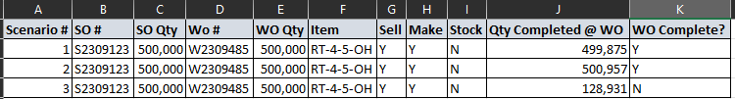
#1 use the SO Qty
#2 Use the SO Qty
#3 use the SO Qty

Part III – Change Order Details

Date | Enhancement | Requested By | Notes | Priority | Release Status
08/24/23 | Updated the document as it has been nearly a year since last looked at and some requirements changed.  Will require another review and quote. | Brian Chapple |  | 1

